Pure vs. Impure

1. In your own words, describe the difference between pure and impure.

2. The curves below were obtained by a student after heating two solid substances A & B.
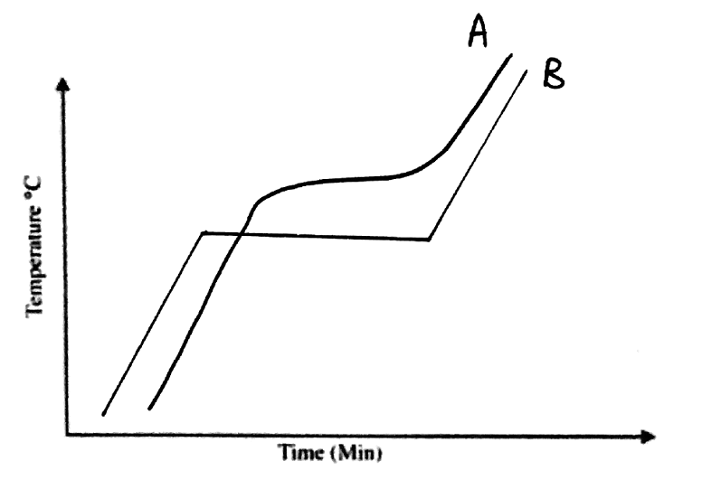
a) Which substance (A or B) has the higher melting point? …………………….

b) Explain which curve represents an impure substance? ………………………………………………..
…………………………………………………………………………………………………………………
…………………………………………………………………………………………………………………

3. According to our definitions H₂O (water) is a compound. However, it is sometimes called a molecule. O₂ (oxygen gas) is also a molecule. Use this sentence to define a molecule.

A ____________ consists of _______ or more _________ chemically __________ together. These _______ can be of the same _________ or different elements.

Extension: There are around 100 different elements. How many compounds do you think there are?
(Hint: think about how many different combinations you could make with just 3 different elements.)

